## dormakaba 91 60-K5 QR code

#### Rationale for the realization of this functionAfter reading the QR code, the access policy is realized according to the "verification method".

QR code content and use process:

(1). The user (or visitor) record is sent to the device in advance by the host computer through WEB API.

(2). The content of QR code is cipher text: user (or visitor) IC card number + time encrypted with initial key.

(3). When the device reads it, it will decrypt it with the initial key of the device, and after successful decryption, it will be able to find this IC card number record in the device, and determine whether the time is valid (e.g., within 3 seconds), and if it is normal, it will pass.：

#### QR code data format：

example：{"iccard": "2f2433c1","expiry":"2021-07-20T00:00:00,2021-07-20T23:59:59","authDevices": [{"sn": "YGKJ2021DM0800003"}]}

|  |  |  |  |
| --- | --- | --- | --- |
| 字段名 | 类型 | 说明 |  |
| iccard | String | User card number |  |
| expiry | String | Expiry date, start time and end time, separated by commas, and date and hour separated by a capital T (ISO 8601) |  |
| authDevices | Json arrays | Equipment authorized for passage |  |
| sn | String | Serial number of the device authorized to pass |  |
|  |  |  |  |

#### QR code encryption

Online Encryption Tool：<https://anycript.com/>

encryption key：abcdefgh12345678（Tentative test）

The encryption parameters are shown below：

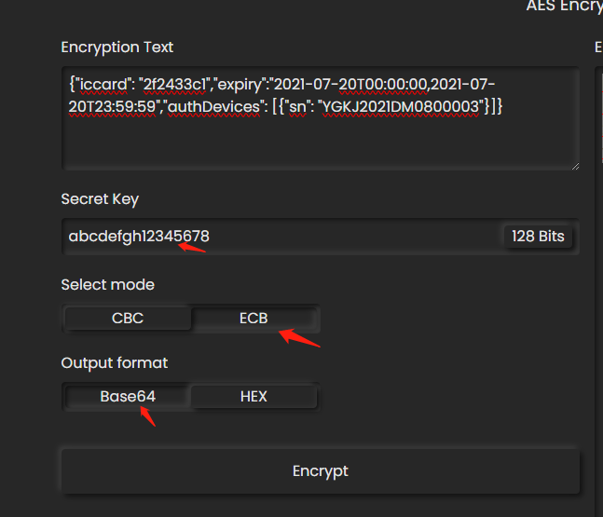

#### Generation of QR codes：

Copy the BASE64 string generated by AES encryption to https: <https://www.the-qrcode-generator.com/>

